**COMPUTER SOFTWARE**

**LAB: 02**



**Fall-21**

[**CSE-102L Computer Fundamental Lab**](https://classroom.google.com/u/2/c/MzA5OTAwMDgwMjI2)

Submitted by: **Amir Suliman**

Registration No: **19PWCSE1805**

Class Section: **B**

“On my honor, as a University of Engineering and Technology student, I have neither given nor received unauthorized assistance on this academic work.”

Student Signature: ______________

Submitted to:

**Engr. Abdullah Hamid**

March 18, 2022

Department of Computer Systems Engineering

University of Engineering and Technology, Peshawar

**Steps involved in installing window:**

**Step1:**

Open your browser and go to download the iso file of a window.

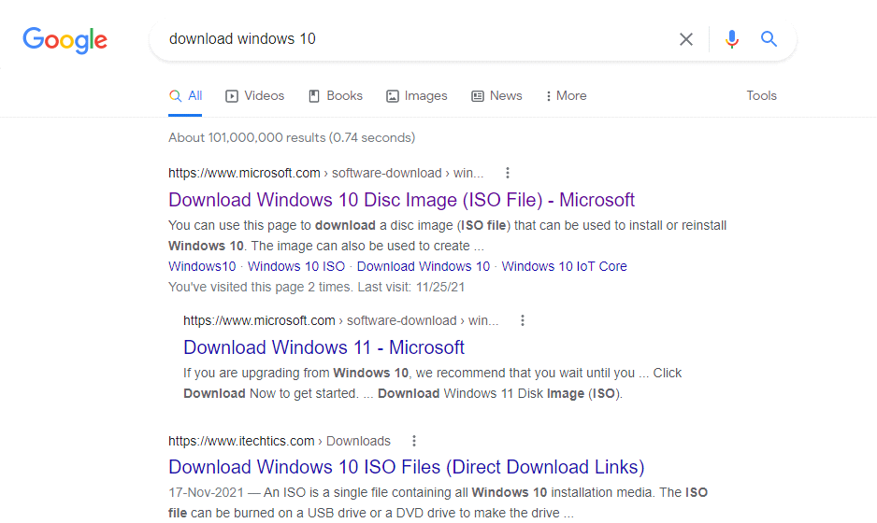

**Step2:**

After downloading the iso file there will be 2 options.

1. Upgrade now 2. Download tool now

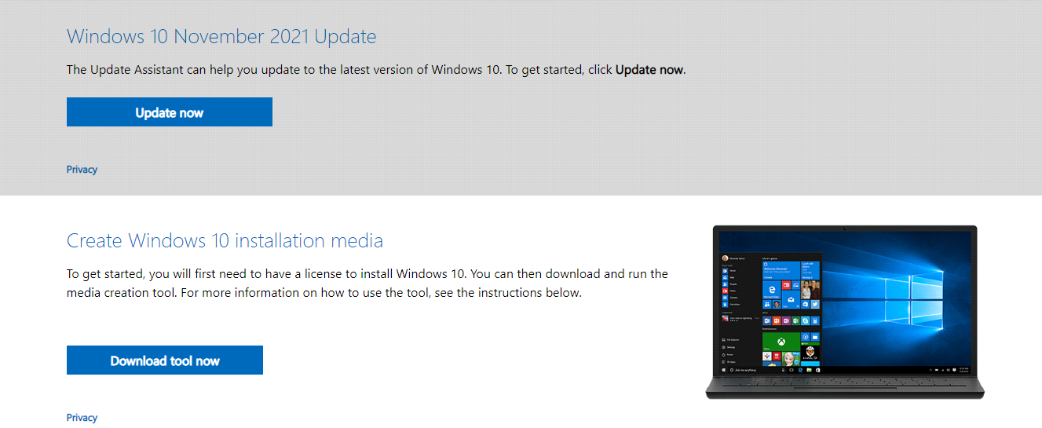

**Step3:**

Click on the Download tool now to download and install the window.

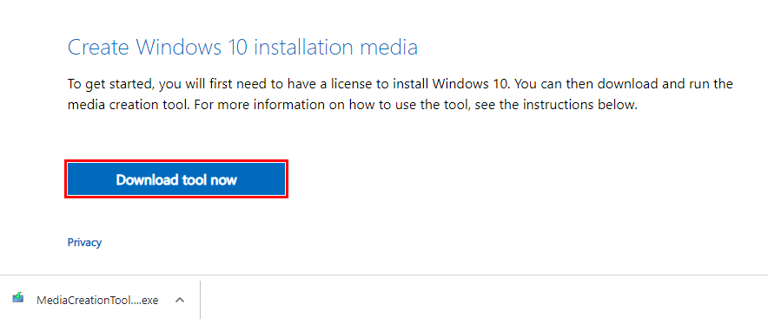

**Step4:**

After downloading double click on the .exe file. You will be prompted to the following window. Click on the yes option to start the installation process.

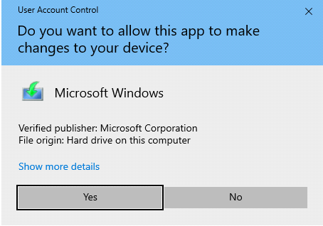

**Step5:**

When the Windows 10 Media Creation Tool loads its user interface, it asks you to accept its license terms. Read the terms, and click accept to continue.

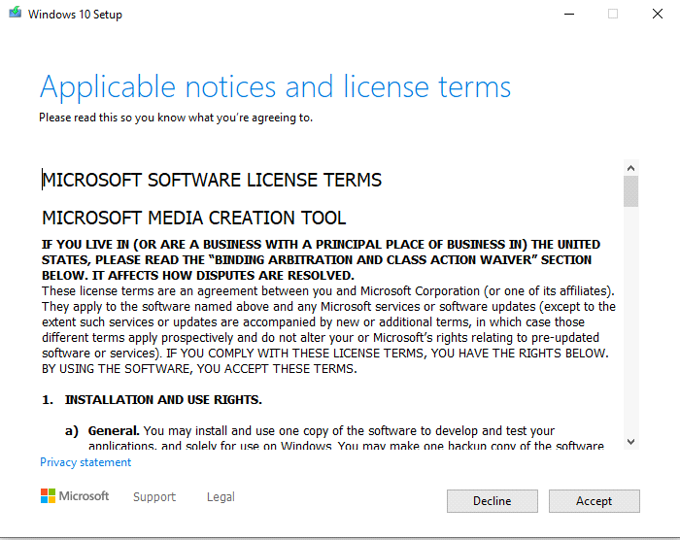

**Step6:**

Media Creation Tool requires a few seconds to "get a few things ready." Then, it asks whether you want to upgrade your PC or create installation media. Select "Create installation media (USB flash drive, DVD, or ISO file) for another PC," and then click Next**.**

**Note:** You must insert your USB drive to start the installation.

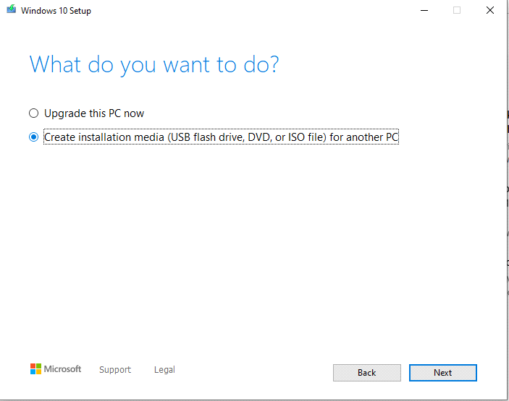

**Step7:**

In this step, you have to choose the language, Edition, and Architecture. Media tools also recommend options. you may use recommended options or can enter options of your own.

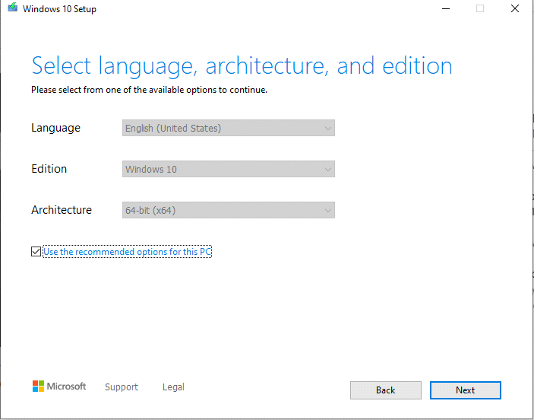

**Step8:**

In this step select USB flash drive and then click on next.

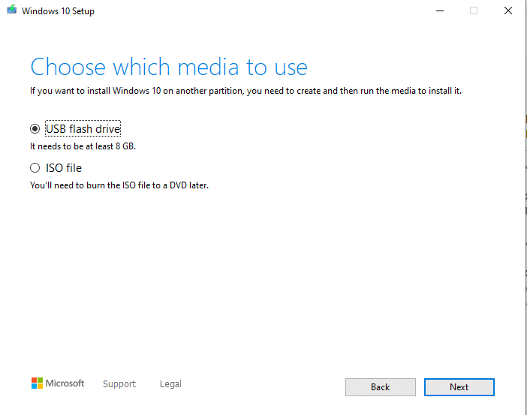

**Step9:**

Now refresh drive list and select the name of your USB drive and then click next.

Once you have selected the USB flash drive, the Windows 10 Media Creation Tool starts to download the latest installation files.

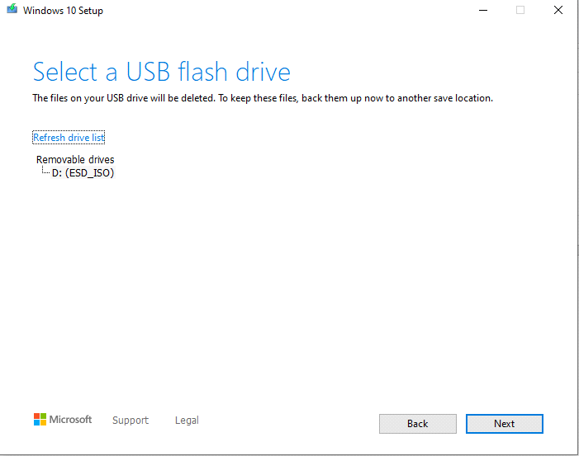

**Step10:**

When the process is finished, you are informed that the USB memory stick is ready. Click or tap Finish, and then you can use that drive to boot from and install Windows 10.

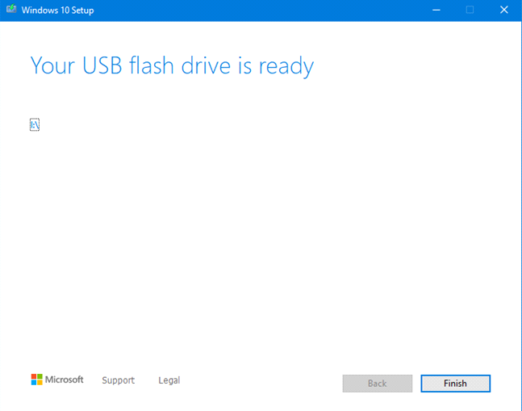

**Installing Window 10 From Bootable Usb:**

**Step1:**

Boot your computer using the installation disc, USB flash drive with the Windows 10 installation. In a couple of seconds, you see a quick message on the screen stating that you need to press any key to continue. The screen will then show language set options

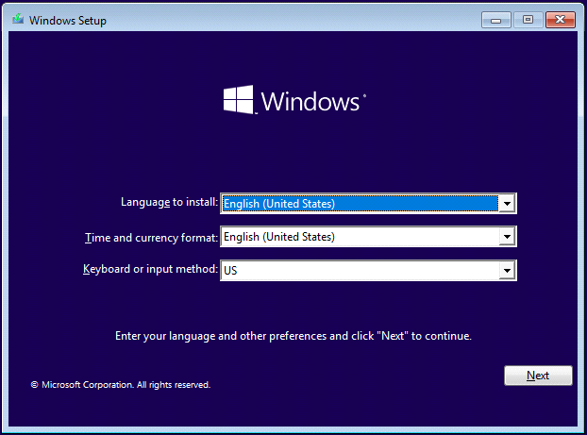

change the language according to your choice.

**Step2:**

These steps require permission from the user to start the installation process

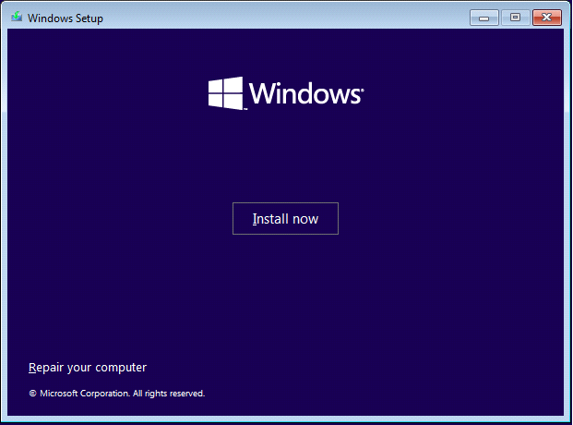

**Step3:**

Step 2 takes some time and then the next process will be displayed. In this step, the program will require some code to activate the window. In case of not having an activation code, you can tap on "I don't have it".

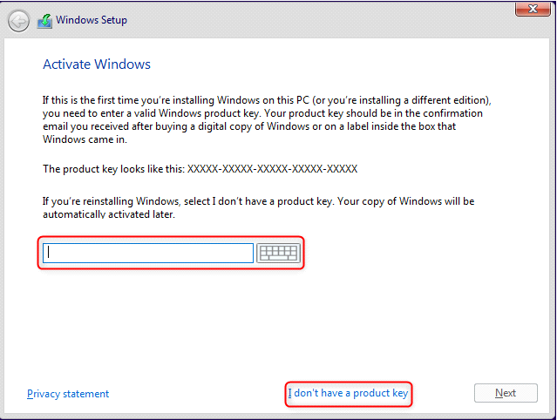

**Step4:**

The next process will require the choice of the user while choosing the window to be installed. It will give multiple options and the user select according to his preferences.

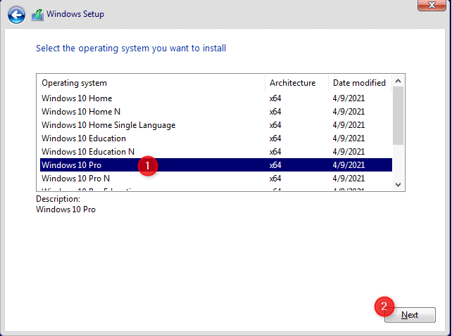

**Step5:**

After choosing the window you will be shown a license. You have to click "I accept the license" and press next to proceed.

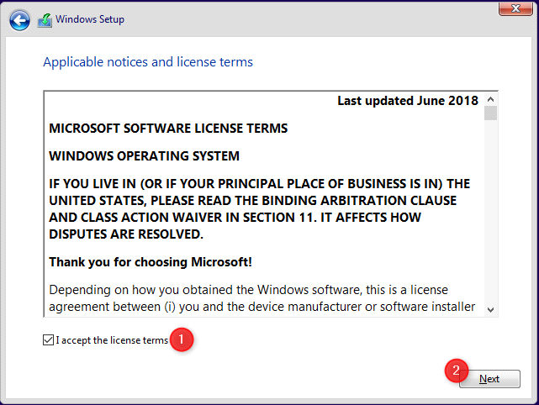

**Step6:**

You are asked for the type of installation you want to perform. To make a clean install of Windows 10, click or tap "Custom: Install Windows only (advanced)." Otherwise, choose Upgrade.

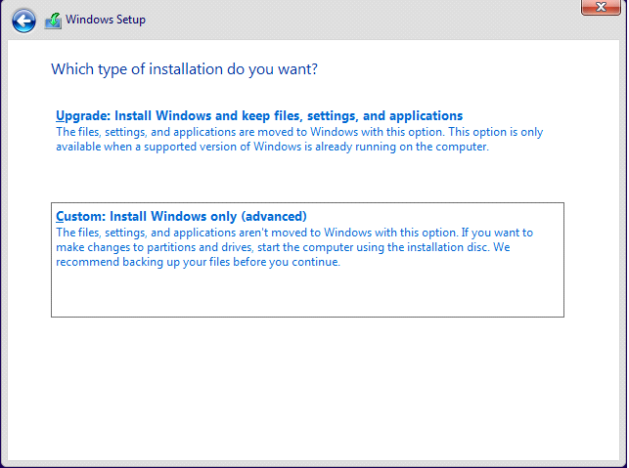

**Step7:**

You are asked to select where you want to install Windows and will be given the choice to do a partition. Choose the drive or partition that you want to use for Windows 10 and press Next. You are asked to select where you want to install Windows.

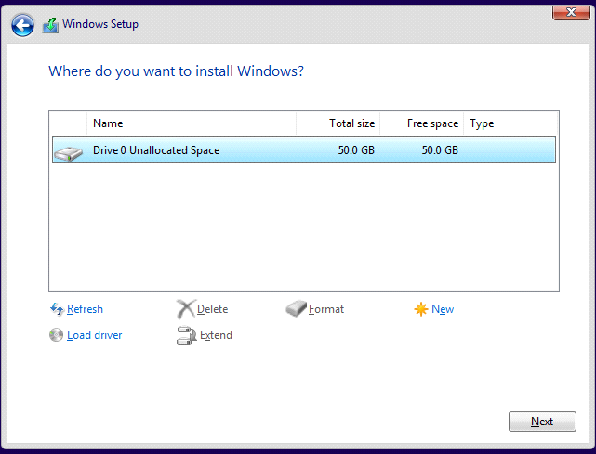

If you need to configure your partitions in a specific way, do not hesitate to use the tools available for creating new partitions, deleting old ones, formatting, and so on before clicking Next.

**Step8:**

The setup takes some minutes to copy all the required files, and then it installs Windows 10.

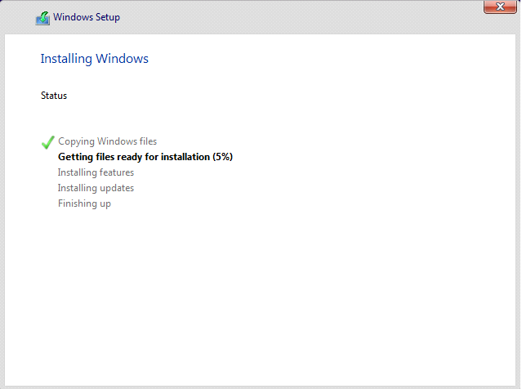

**Step9:**

Once the installation is done, the Windows 10 setup automatically reboots at least once, to run the first-time configuration scripts.

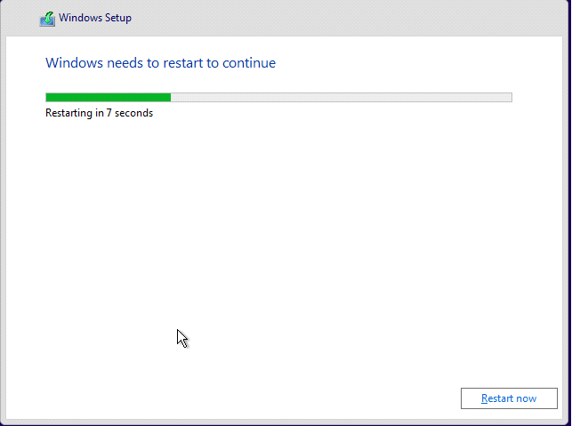

**Step10:**

While you wait, Windows 10 shows you the status of its "Getting ready" activities.

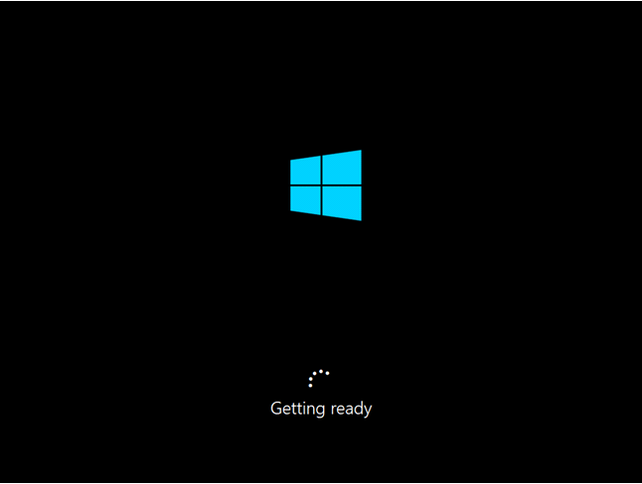

**Step11:**

After the reboots are finished, Windows 10 asks you to choose the region where you live. Select your country from the list, and then click or tap Yes**.**

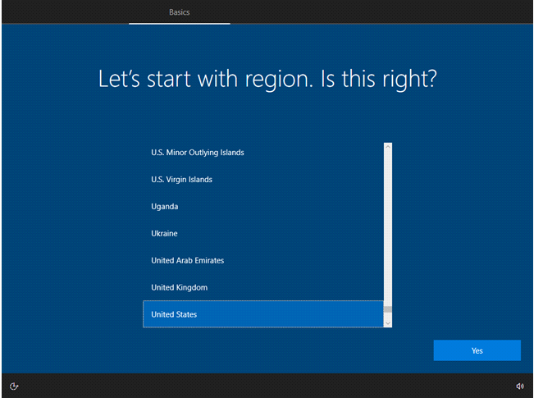

**Step12:**

You are asked to select how you want to set up Windows 10. If your computer belongs to an organization select "Set up for an organization" and use your business account to sign in and access your resources. Otherwise, choose "Set up for personal use" and press Next.

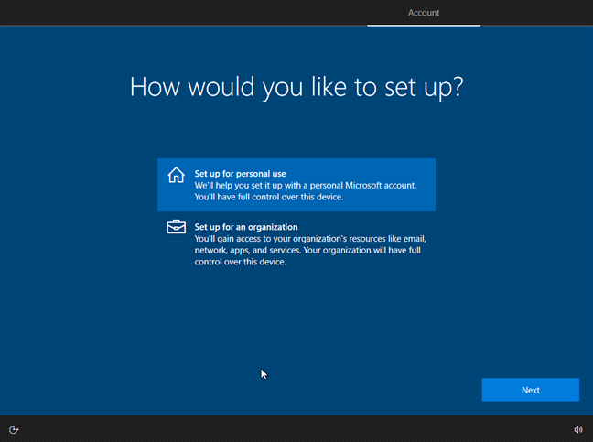

**Step13:**

You are asked to sign in with your Microsoft account. If you want to do so, enter your credentials and click or tap Next.

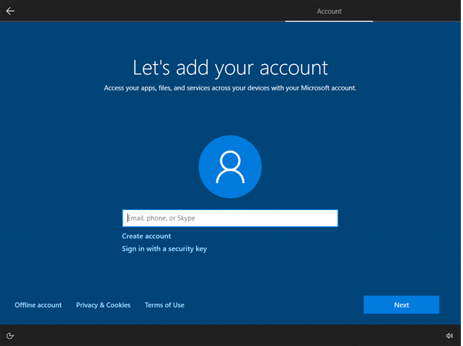

Otherwise, if you're going to use a local account on your Windows 10 PC, skip to the next section of this guide.

**Step14:**

In this step, you have to provide a Microsoft account to confirm our authentication and to proceed further.

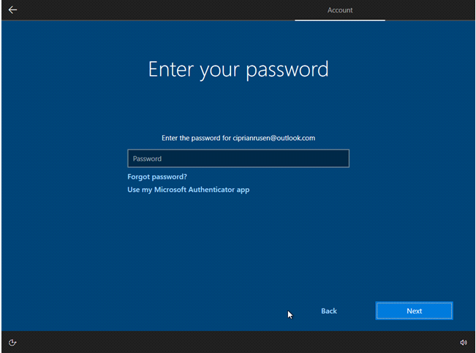

**Step15:**

In this step, you have been given the choice to create a PIN for security. It depends on the user whether he/she wants to create a PIN or leave it.

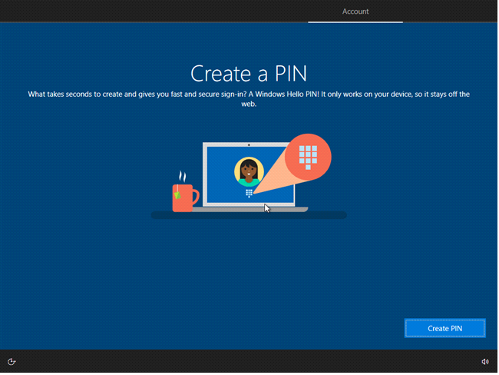

**Step16:**

Now you're asked about choosing the privacy settings for your device. Select whether you want to enable or disable features like Location, Diagnostic data, Find my device, or Advertising ID. We recommend that you carefully read what all options do and turn on only those you feel comfortable with. Press Accept when you are done.

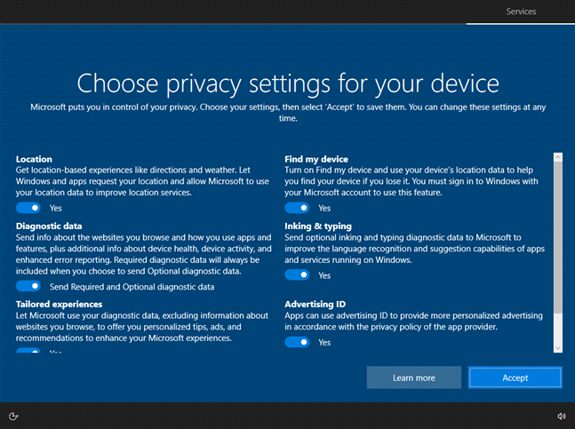

**Step17:**

Choose whether you want to use Cortana as your digital assistant. To enable her, press Accept. To disable her press Not now.

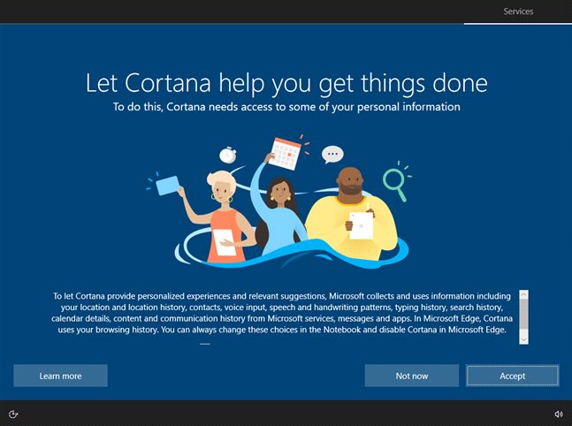

**Step18:**

Windows 10 takes a while to prepare everything and be ready for use. Wait for a bit.

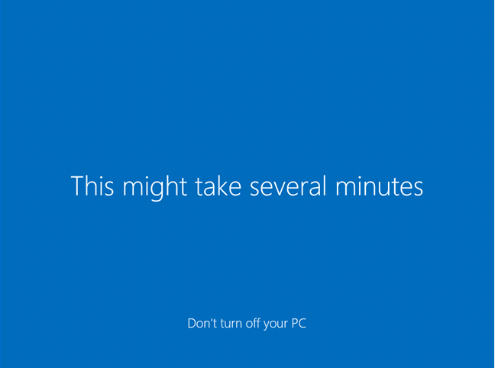

Now your computer is ready for use.

